25 Video Lectures – Reading from other sources

**There’s an R package for that**

1. there is an r-package for most things you wish to access
2. just go look it up!
3. when in doubt, google “MySQL R Package.”

**Interacting more directly with local files**

1. file() – opens a connection to a text file
2. url() – opens a connection to a URL
3. gzfile() – opens a connection to a .gz file (zip files)
4. bzfile() – opens a connection to a .bz2 file (zip files)
5. ?connections gives more connections to review
6. always close your connections

**foreign package**

Loads files for a buncha different file formats

basic functions:

1. read.arff (for a weka)
2. read.dta (for a Stata)
3. read.mtp (for a Minitab)
4. read.octave (for an octave file)
5. etc

**Other packages**

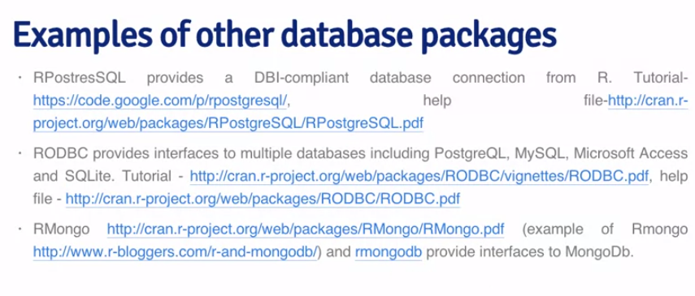

**Read Images**

manipulate a picture in R… ooooh fancy

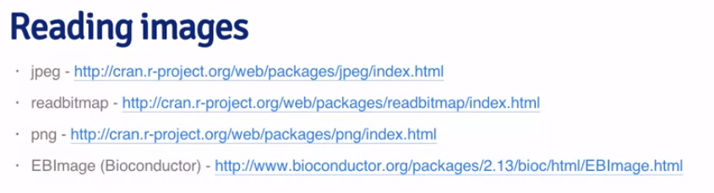

**Ever want to analyze a song?**

